InPen™ Smart Insulin Pen MEDICAL DEVICE CORRECTION - SPECIALTY/CLINICAL COUNSELING TALK TRACK

Background Information: On March 10, 2025, Medtronic issued a Medical Device Correction of InPen™ Smart Insulin Pens. This medical device correction was issued because some InPen™ Smart Insulin Pens have been identified with an issue that can cause difficulty in removing the cartridge holder or installing the insulin cartridge into the cartridge holder. Some InPens from certain lots may have been incorrectly assembled.

For affected InPens, users could potentially experience either one of two issues:

- Either the insulin cartridge will not fit into the cartridge holder

- Or the cartridge holder may be difficult to remove from the insulin pen, requiring a significant amount of force.

According to Medtronic, an InPen with an insulin cartridge that will not fit into the cartridge holder cannot be used. An InPen with a cartridge holder that is difficult to remove should not be used even if you are able to do so. If you do not have backup insulin when you need it, you may experience temporary hyperglycemia.

Between May 2024 and November 2024, Medtronic received 31 complaints potentially related to this issue. There have not been any serious adverse events associated with these complaints.

Clinical Care Service/Specialty Pharmacy Talk Track

Clinical Care Technicians - Please ensure to disposition all recall calls to code “1456”
Clinical Care Pharmacists - Please ensure to disposition all recall calls to code “1408”

Q# | Question | Action | Answer
1 | I heard that there is Medical Device Correction with my InPen™ Smart Insulin Pen. Can you give me more information? | Note: Check PeopleSafe to determine if the medication is from Mail or Specialty Pharmacy | If the medication was dispensed from… | Then say…
1 |  |  | Mail Order | - Yes, I can.  - Proceed to Q2
1 |  |  | Specialty | While in PeopleSafe, determine the phone number of the dispensing Specialty pharmacy and transfer the call.  A: Yes, I can. Please hold while I transfer you to your Specialty Pharmacy.

Customer Care/Specialty Talk Track Clinical Care Service/Specialty Pharmacy Talk Track
2 | Why is there a Medical Device Correction? What is wrong with the product? |  | On March 10, 2025, Medtronic issued a Medical Device Correction of InPen™ Smart Insulin Pens. This Medical Device Correction was issued because some InPen™ Smart Insulin Pens have been identified with an issue that can cause difficulty in removing the cartridge holder or installing the insulin cartridge into the cartridge holder.  For more information, call Medtronic toll-free at 1-800-646-4633, option 1. You may also call the United States Food and Drug Administration (FDA) toll-free at 1-888-INFO-FDA (1-888-463-6332) or visit www.fda.gov.
3 | May I return the rest of the InPen™ Smart Insulin Pen that I have? | Determine if the patient is affected by this recall | First, let’s determine if you are affected by this recall:
3 |  | Determine if the patient is affected by this recall | If the product was dispensed in… |  | Then say...
3 |  | Determine if the patient is affected by this recall | Manufacturer’s Package |  | - Check the lot number. The lot number is located on the fold-over label affixed to the InPen box/carton or on the dose knob portion of the InPen.  - If your product is not from this affected lot number, it is not affected by this Medical Device Correction.  1. If you have already inserted your insulin cartridge into your InPen and are using your InPen without difficulty removing the cartridge holder, then your InPen is not affected by this issue, and you can continue to use your InPen as normal.  2. Locate the lot number for your InPen.  3. Verify if your lot number matches one of the impacted lot numbers listed at the top of this letter.  4. If you have an InPen from one of the affected lot numbers listed at the top of this letter and have not yet started using it or have had difficulties in removing the cartridge holder or inserting the insulin cartridge, please call 1-800-646-4633, option 1, or go to https://info.medtronicdiabetes.com/ICH-replacement-form to request a replacement InPen. Do not use this InPen and return it according to Medtronic’s replacement instructions

Affected Product | NDC | Lot Number
INPEN (NOVOLOG OR FIASP) BLUE  MODEL/CFN: MMT-105NNBLNA | 63000-0827-18 | D0020
INPEN (NOVOLOG OR FIASP) BLUE  MODEL/CFN: MMT-105NNBLNA | 63000-0827-18 | D0034
INPEN (NOVOLOG OR FIASP) BLUE  MODEL/CFN: MMT-105NNBLNA | 63000-0827-18 | D0036
INPEN (NOVOLOG OR FIASP) BLUE  MODEL/CFN: MMT-105NNBLNA | 63000-0827-18 | D0038
INPEN (NOVOLOG OR FIASP) BLUE  MODEL/CFN: MMT-105NNBLNA | 63000-0827-18 | D0045
INPEN (NOVOLOG OR FIASP) BLUE  MODEL/CFN: MMT-105NNBLNA | 63000-0827-18 | D0046
INPEN (NOVOLOG OR FIASP) BLUE  MODEL/CFN: MMT-105NNBLNA | 63000-0827-18 | D0050
INPEN (NOVOLOG OR FIASP) BLUE  MODEL/CFN: MMT-105NNBLNA | 63000-0827-18 | D0057
INPEN (NOVOLOG OR FIASP) BLUE  MODEL/CFN: MMT-105NNBLNA | 62088-0000-34 | D0020
INPEN (NOVOLOG OR FIASP) BLUE  MODEL/CFN: MMT-105NNBLNA | 62088-0000-34 | D0034
INPEN (NOVOLOG OR FIASP) BLUE  MODEL/CFN: MMT-105NNBLNA | 62088-0000-34 | D0036
INPEN (NOVOLOG OR FIASP) BLUE  MODEL/CFN: MMT-105NNBLNA | 62088-0000-34 | D0038
INPEN (NOVOLOG OR FIASP) BLUE  MODEL/CFN: MMT-105NNBLNA | 62088-0000-34 | D0045
INPEN (NOVOLOG OR FIASP) BLUE  MODEL/CFN: MMT-105NNBLNA | 62088-0000-34 | D0046
INPEN (NOVOLOG OR FIASP) BLUE  MODEL/CFN: MMT-105NNBLNA | 62088-0000-34 | D0050
INPEN (NOVOLOG OR FIASP) BLUE  MODEL/CFN: MMT-105NNBLNA | 62088-0000-34 | D0057
INPEN (NOVOLOG OR FIASP) GREY  MODEL/CFN: MMT-105NNGYNA | 63000-0827-19 | D0026
INPEN (NOVOLOG OR FIASP) GREY  MODEL/CFN: MMT-105NNGYNA | 63000-0827-19 | D0037
INPEN (NOVOLOG OR FIASP) GREY  MODEL/CFN: MMT-105NNGYNA | 63000-0827-19 | D0039
INPEN (NOVOLOG OR FIASP) GREY  MODEL/CFN: MMT-105NNGYNA | 63000-0827-19 | D0041
INPEN (NOVOLOG OR FIASP) GREY  MODEL/CFN: MMT-105NNGYNA | 63000-0827-19 | D0042
INPEN (NOVOLOG OR FIASP) GREY  MODEL/CFN: MMT-105NNGYNA | 63000-0827-19 | D0043
INPEN (NOVOLOG OR FIASP) GREY  MODEL/CFN: MMT-105NNGYNA | 63000-0827-19 | D0049
INPEN (NOVOLOG OR FIASP) GREY  MODEL/CFN: MMT-105NNGYNA | 62088-0000-35 | D0026
INPEN (NOVOLOG OR FIASP) GREY  MODEL/CFN: MMT-105NNGYNA | 62088-0000-35 | D0037
INPEN (NOVOLOG OR FIASP) GREY  MODEL/CFN: MMT-105NNGYNA | 62088-0000-35 | D0039
INPEN (NOVOLOG OR FIASP) GREY  MODEL/CFN: MMT-105NNGYNA | 62088-0000-35 | D0041
INPEN (NOVOLOG OR FIASP) GREY  MODEL/CFN: MMT-105NNGYNA | 62088-0000-35 | D0042
INPEN (NOVOLOG OR FIASP) GREY  MODEL/CFN: MMT-105NNGYNA | 62088-0000-35 | D0043
INPEN (NOVOLOG OR FIASP) GREY  MODEL/CFN: MMT-105NNGYNA | 62088-0000-35 | D0049
INPEN (NOVOLOG OR FIASP) PINK  MODEL/CFN: MMF-105NNPKNA | 63000-0827-20 | D0029
INPEN (NOVOLOG OR FIASP) PINK  MODEL/CFN: MMF-105NNPKNA | 63000-0827-20 | D0030
INPEN (NOVOLOG OR FIASP) PINK  MODEL/CFN: MMF-105NNPKNA | 63000-0827-20 | D0040
INPEN (NOVOLOG OR FIASP) PINK  MODEL/CFN: MMF-105NNPKNA | 63000-0827-20 | D0051
INPEN (NOVOLOG OR FIASP) PINK  MODEL/CFN: MMF-105NNPKNA | 63000-0827-20 | D0062
INPEN (NOVOLOG OR FIASP) PINK  MODEL/CFN: MMF-105NNPKNA | 62088-0000-36 | D0029
INPEN (NOVOLOG OR FIASP) PINK  MODEL/CFN: MMF-105NNPKNA | 62088-0000-36 | D0030
INPEN (NOVOLOG OR FIASP) PINK  MODEL/CFN: MMF-105NNPKNA | 62088-0000-36 | D0040
INPEN (NOVOLOG OR FIASP) PINK  MODEL/CFN: MMF-105NNPKNA | 62088-0000-36 | D0051
INPEN (NOVOLOG OR FIASP) PINK  MODEL/CFN: MMF-105NNPKNA | 62088-0000-36 | D0062
INPEN (FOR HUMALOG) BLUE  MODEL/CFN: MMT-105ELBLNA | 63000-0827-15 | D0021
INPEN (FOR HUMALOG) BLUE  MODEL/CFN: MMT-105ELBLNA | 63000-0827-15 | D0033
INPEN (FOR HUMALOG) BLUE  MODEL/CFN: MMT-105ELBLNA | 63000-0827-15 | D0035
INPEN (FOR HUMALOG) BLUE  MODEL/CFN: MMT-105ELBLNA | 63000-0827-15 | D0044
INPEN (FOR HUMALOG) BLUE  MODEL/CFN: MMT-105ELBLNA | 63000-0827-15 | D0059
INPEN (FOR HUMALOG) BLUE  MODEL/CFN: MMT-105ELBLNA | 63000-0827-15 | D0060
INPEN (FOR HUMALOG) BLUE  MODEL/CFN: MMT-105ELBLNA | 63000-0827-15 | D0061
INPEN (FOR HUMALOG) BLUE  MODEL/CFN: MMT-105ELBLNA | 62088-0000-31 | D0021
INPEN (FOR HUMALOG) BLUE  MODEL/CFN: MMT-105ELBLNA | 62088-0000-31 | D0033
INPEN (FOR HUMALOG) BLUE  MODEL/CFN: MMT-105ELBLNA | 62088-0000-31 | D0035
INPEN (FOR HUMALOG) BLUE  MODEL/CFN: MMT-105ELBLNA | 62088-0000-31 | D0044
INPEN (FOR HUMALOG) BLUE  MODEL/CFN: MMT-105ELBLNA | 62088-0000-31 | D0059
INPEN (FOR HUMALOG) BLUE  MODEL/CFN: MMT-105ELBLNA | 62088-0000-31 | D0060
INPEN (FOR HUMALOG) BLUE  MODEL/CFN: MMT-105ELBLNA | 62088-0000-31 | D0061
INPEN (FOR HUMALOG) GREY  MODEL/CFN: MMT-105ELGYNA | 63000-0827-16 | D0031
INPEN (FOR HUMALOG) GREY  MODEL/CFN: MMT-105ELGYNA | 63000-0827-16 | D0032
INPEN (FOR HUMALOG) GREY  MODEL/CFN: MMT-105ELGYNA | 63000-0827-16 | D0047
INPEN (FOR HUMALOG) GREY  MODEL/CFN: MMT-105ELGYNA | 63000-0827-16 | D0068
INPEN (FOR HUMALOG) GREY  MODEL/CFN: MMT-105ELGYNA | 62088-0000-32 | D0031
INPEN (FOR HUMALOG) GREY  MODEL/CFN: MMT-105ELGYNA | 62088-0000-32 | D0032
INPEN (FOR HUMALOG) GREY  MODEL/CFN: MMT-105ELGYNA | 62088-0000-32 | D0047
INPEN (FOR HUMALOG) GREY  MODEL/CFN: MMT-105ELGYNA | 62088-0000-32 | D0068
INPEN (FOR HUMALOG) PINK  MODEL/CFN: MMT-105ELPKNA | 63000-0827-17 | D0027
INPEN (FOR HUMALOG) PINK  MODEL/CFN: MMT-105ELPKNA | 63000-0827-17 | D0028
INPEN (FOR HUMALOG) PINK  MODEL/CFN: MMT-105ELPKNA | 63000-0827-17 | D0048
INPEN (FOR HUMALOG) PINK  MODEL/CFN: MMT-105ELPKNA | 62088-0000-33 | D0027
INPEN (FOR HUMALOG) PINK  MODEL/CFN: MMT-105ELPKNA | 62088-0000-33 | D0028
INPEN (FOR HUMALOG) PINK  MODEL/CFN: MMT-105ELPKNA | 62088-0000-33 | D0048

Additional Information:

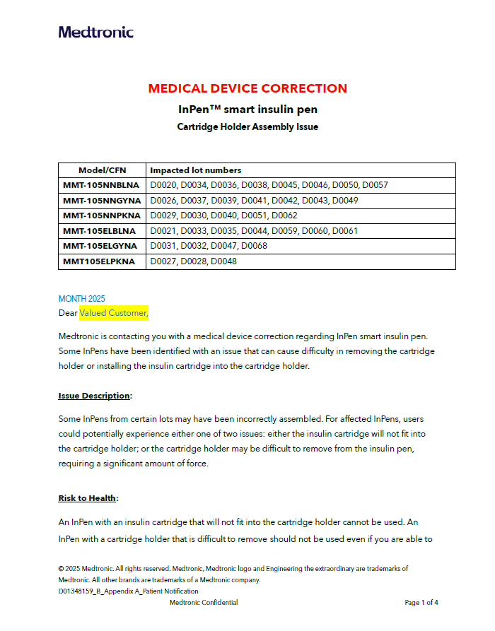

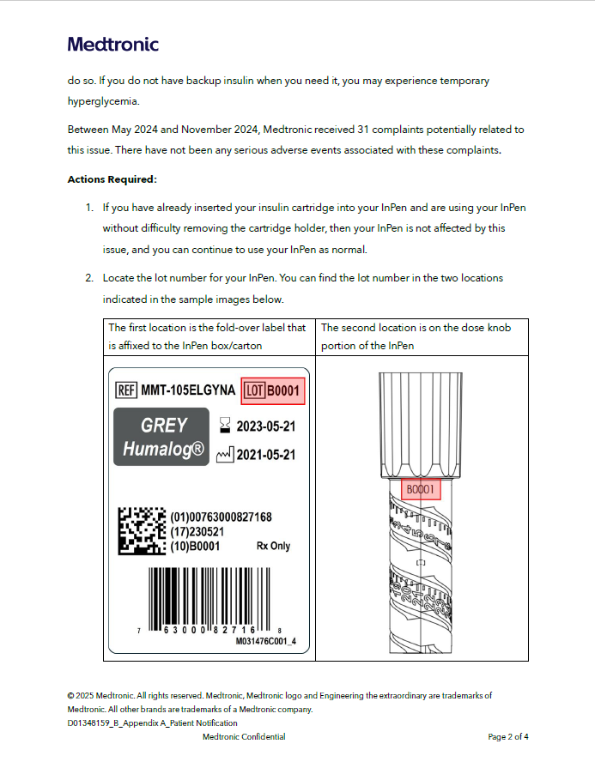

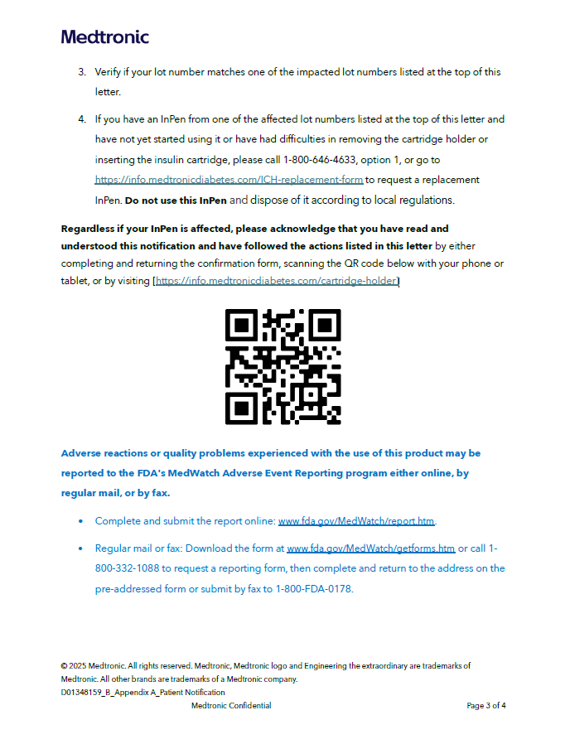

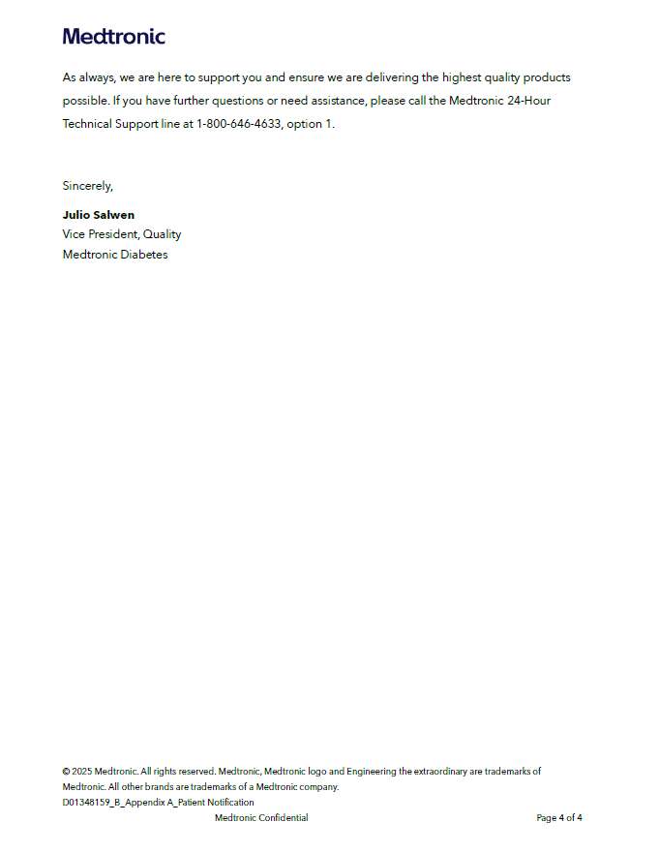

Top of the Document
Not to Be Reproduced or Disclosed to Others without Prior Written Approval
ELECTRONIC DATA = OFFICIAL VERSION / PAPER COPY = INFORMATIONAL ONLY

